**Ariel Lin**

**Taiwanese Actress and Singer**

Ariel Lin is one of the most talented Taiwanese actresses in living memory. Apart from being an actress she is also a singer. She is 1.6 meters tall, light skinned, pretty and with a very attractive figure. Ariel first got her chance to showcase her talents in a Taiwanese variety show *Guess Guess Guess* in which she emerged as the champion of the pretty subway girl contest.



She was selected to play the role of Lin Laisui in Tokyo Juliet (2004) alongside Wu Chun and Simon Yam; a role in which she excelled and attracted the attention of producers. In the same year, she also starred in her fist film *Love Me, If You Can* (2004). She was nominated for Best Actress Award for this performance. Thereafter, she entered the limelight with her role as Yuan Xiangqin in the 2005 Taiwanese Drama, *It Started with a Kiss.*



She followed this up quickly in 2006 with a Chinese fantasy drama, *The little Fairy* in which she appeared as the Seventh Fairy Maiden and before anyone knew it, she positioned herself with a dazzling performance to win two trophies at the 43rd and 47th Golden Bell Awards for her extraordinary performance in *They Kiss Again* (2007) and *In Time with You* (2011) respectively.

Her popularity continued to soar with every role she played and by 2008 her fame had spread to Mainland China, especially after her role as Huang Rong in *The Legend of the Condor Heroes* (2008).

She is one of two women who have been able to win multiple Best Actress awards at the one and only Golden Bell Awards in Taiwan. She received the Best Actress awards in both instances.



The two awards, particularly the one for her role in “In Time with You” represented significant landmarks not only for her career but also for Taiwanese drama as a whole. The two films provided the world with an opportunity to glimpse and appreciate Taiwanese drama and culture at a close range for the first time.



Ariel Lin is one of the few women in the acting profession to be declared free from scandals and any gossips attached to her personality and has therefore earned the nickname “Queen of Zero Scandals” in the Taiwanese media.

Ariel comes from a middle class family and was born on October 29 1982 in Yilan. There were only two children in the family, Ariel and her younger brother. However, at an early age she experienced the trauma of her parents divorcing and being left in the care of her mother who could not maintain the living standards she had become accustomed to. Consequently, she lived in poverty for quite a long time.

In 2014, as a result of her efforts to reconcile the parents, the family was reunited gain. Ariel put all her efforts into studying during the blissful period and she managed to obtain a BA degree in Korean and Literature from National Chengchi University in 2005. She followed this up in 2014 with a Master’s degree in Screen Acting from the Royal Central School of Speech and Drama of the University of London. She got married soon after to a businessman, Charles Lin, in 2014.

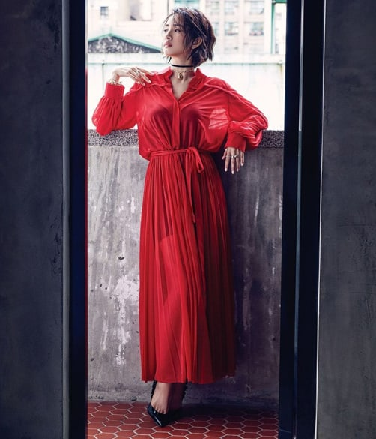

Although Ariel has appeared in an endless list of television series and films, she still found time to further her singing career. In 2009, after signing a contract with Avex *Taiwan* she released an album that sold over 20, 000 copies in a matter of days. The title of the Album was Blissful *Encounter*. Also in 2009, she appeared in the theater play, *The War and Peace* *between Men and Women* as the star of the musical. However, in recent years Ariel has concentratd on films. She starred in several films between 2013 and 2017 including the crime caper *Sweet Alibis* alongside Alec Su, *Go Lala Go 2* (2015), the sequel to the 2010 hit film *Go Lala Go!*, and the thriller *The Mysterious Family* (2017)